Bhartiyam International School
Periodic Assessment-1(2022-23)
Subject: EVS (Set-B)
Class: II
Date: 13/07/2022 Max. Mark: 20
Name: ______________ Roll No: ______ Duration: 1 hr
Instructions:
- All the questions are compulsory.
- Attempt all the questions in neat and clean handwriting.
A. Choose the correct options: (0.5x6=3)
1. I hear the bell ringing with my ________________
a) ears b) eyes c) feel d) tongue
2. The first help given to an injured person is called __________________.
a) doctor b) no aid c) first-aid d) safety
3. Which of the following games is an indoor game?
a) Ludo b) Football c) Cricket d) Basketball
4. Keeping away from danger is called _________________.
a) safety b) fire c) injury d) rules
5. Skin helps us to touch and _______________.
a) hear b) see c) feel d) taste
6. Which of the following is an external organ?
a) Brain b) Limbs c) Lungs d) Stomach

B. Match the following: (0.5x6=3)
(1) Limbs (a) form of exercise

(2) Outdoor Game (b) zebra crossing
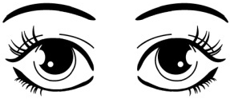
(3) Cross road (c)

(4) Sense organ (d) Arms, Legs

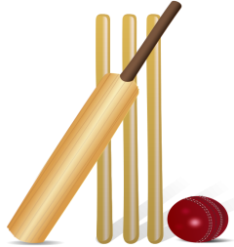
(5) Swimming (e) proper shape to our body

(6) Posture (f)

C. Fill in the blanks: (1x4=4)
1. Exercise keeps us ______________.
2. We must cross road only at the ____________ crossing.
3. Eating _______________ food can make you fall sick.
4. ________________ helps us to think.
D. Write T for true and F for false: (1x4=4)
1. Brain pumps blood.
2. We should not play with sharp objects.
3. Wearing clean clothes is a good habit.
4. Stand in a queue while boarding in the school bus.
E. Answer the following questions: (2x3=6)
1. What is the state of being safe? Write any one safety rule.
____________________________________________________________________________________________________________________________________________________________________________________________________________________________________

____________________________________________________________________________________________________________________________________________________________________________________________________________________________________

2. Write any two good eating habits.
____________________________________________________________________________________________________________________________________________________________________________________________________________________________________

____________________________________________________________________________________________________________________________________________________________________________________________________________________________________

3. Name two external and internal organs (each).
____________________________________________________________________________________________________________________________________________________________________________________________________________________________________

____________________________________________________________________________________________________________________________________________________________________________________________________________________________________

